

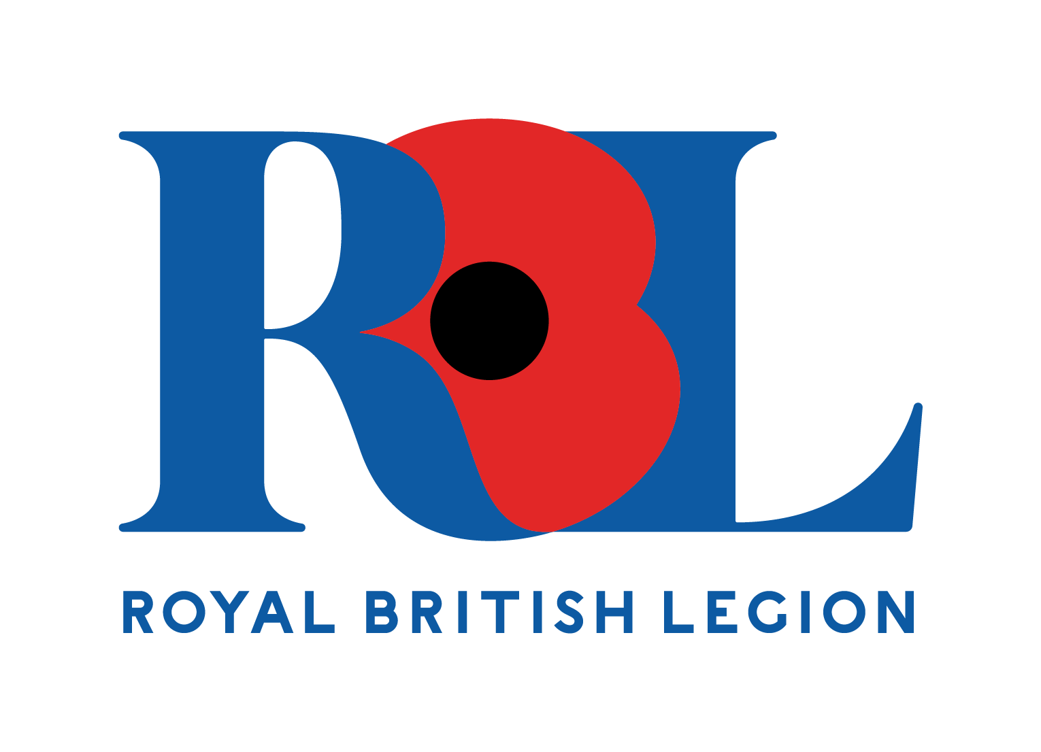

**Briercliffe Primary School**

**raised during Poppy Appeal 2023**

**£348.30**